Sra. Peña
Spanish 7th & 8th
Email: lpena@calvinchr.org
Website: srapena.weebly.com

Course Goals & Objectives:

- Communicate successfully in the Spanish language
- Gain knowledge and understanding of the Spanish Culture
- Connect the Spanish language with other subject areas
- Compare the Spanish language and culture to their own
- Attend a cultural event within the school or Community

Materials needed:
- 3-prong folder or 3 ring binder dedicated only for Spanish
- Loose leaf paper for note taking
- Writing utensil
- An open mind!!!

Participation:
YOU MUST PARTICIPATE! This will be the basis of your grade. In order to learn a language, you must speak and practice as much as possible. Students are expected to engage in student dialogues, skits, presentations and other fun activities as we explore the Spanish language and culture.

Student Expectaions:

Being prepared Disrupting class

Following directions Using technology without permission
Raising your hand Close mindedness
Respectfulness
Being positive & trying your best

Absent?
You are responsible for obtaining any class assignments and notes.

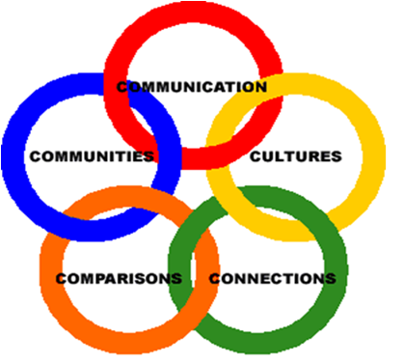

National Standards
for
Foreign Language Education

- COMMUNICATE IN LANGUAGES OTHER THAN ENGLISH
Standard 1.1: Students engage in conversations, provide and obtain information, express feelings and emotions, and exchange opinions
Standard 1.2: Students understand and interpret written and spoken language on a variety of topics
Standard 1.3: Students present information, concepts, and ideas to an audience of listeners or readers on a variety of topics.
- GAIN KNOWLEDGE AND UNDERSTANDING OF OTHER CULTURES

Standard 2.1: Students demonstrate an understanding of the relationship between the practices and perspectives of the culture studied
Standard 2.2: Students demonstrate an understanding of the relationship between the products and perspectives of the culture studied
- CONNECT WITH OTHER DISCIPLINES AND ACQUIRE INFORMATION
Standard 3.1: Students reinforce and further their knowledge of other disciplines through the foreign language
Standard 3.2: Students acquire information and recognize the distinctive viewpoints that are only available through the foreign language and its cultures
- THROUGH COMPARISION DEVELOP INSIGHT INTO THE NATURE OF LANGUAGE AND CULTURE
Standard 4.1: Students demonstrate understanding of the nature of language through comparisons of the language studied and their own
Standard 4.2: Students demonstrate understanding of the concept of culture through comparisons of the cultures studied and their own.
- PARTICIPATE IN MULTILINGUAL COMMUNITIES AT HOME & AROUND THE WORLD
Standard 5.1: Students use the language both within and beyond the school setting
Standard 5.2: Students show evidence of becoming life-long learners by using the language for personal enjoyment and enrichment.

